Quick Guide
X5 Series Client

Adding An X4S

Open the Setup menu

Select the Setup button to the right of the main video screen(s). (Fig. 1-0)

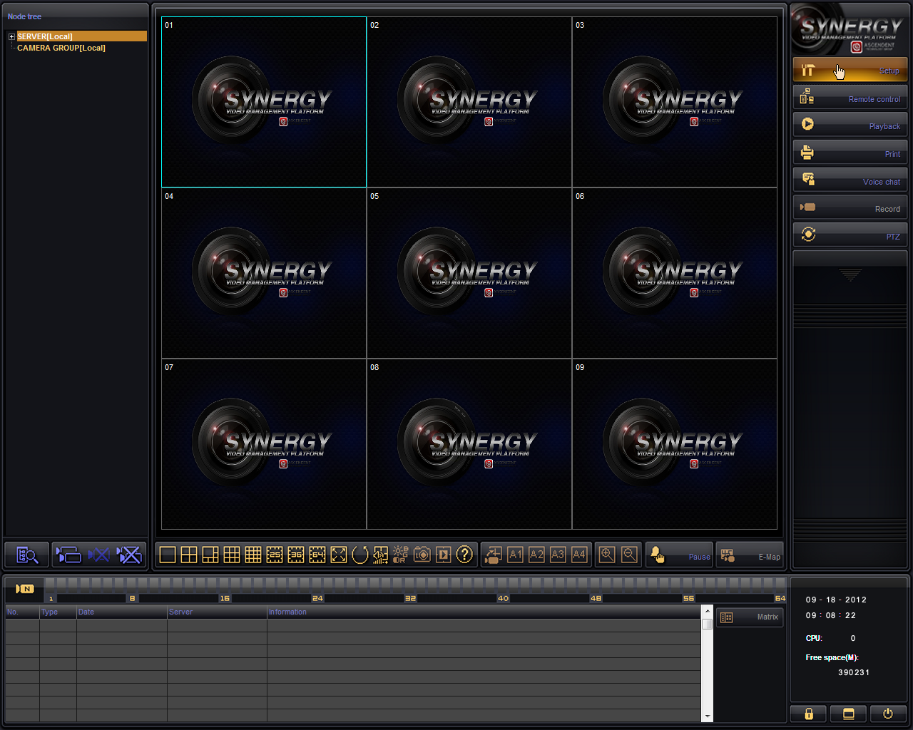
(Fig. 1-0)

Click “OK” after entering your login credentials, the default password for “Supervisor” is blank. Select Server setup in the top left corner and it will open the “Server information” window. At the bottom of the new window click on Show online device then click Discover on the right side of the screen. Select your X4S/IP from the list and ensure that the “Channel number” field contains the number of video feeds on your X4S device. Enter your default password “admin” is the default for X4S devices. (Fig 1-1).

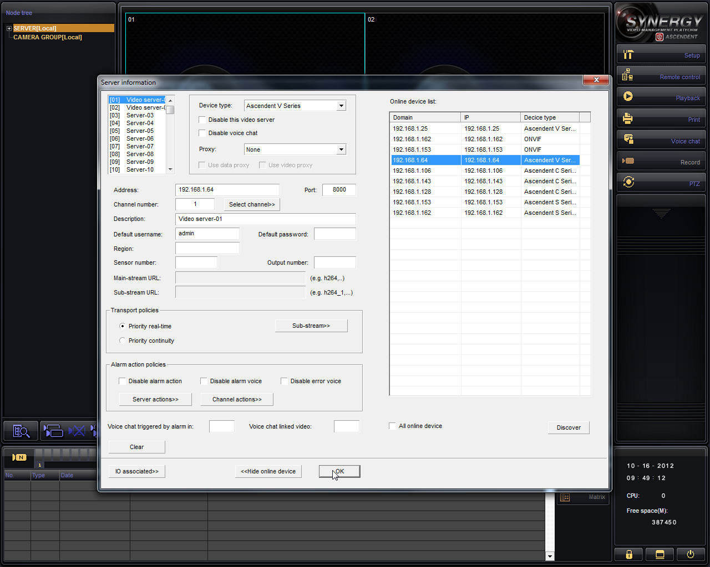
(Fig. 1-1)

After verifying your information click OK and OK again. On the left side of the default window you should see “Server[Local]”, click this to expand it and double-click on DVR.

Zoom

Zoom

Select the Zoom button located below the main video screens (the red circle). On the toolbar that appears on the bottom-middle of the screen click on the (+) symbol to zoom in and the (-) symbol to zoom out. Then simply click and drag your mouse on the video image to move around the image area. (Fig. 2-0)
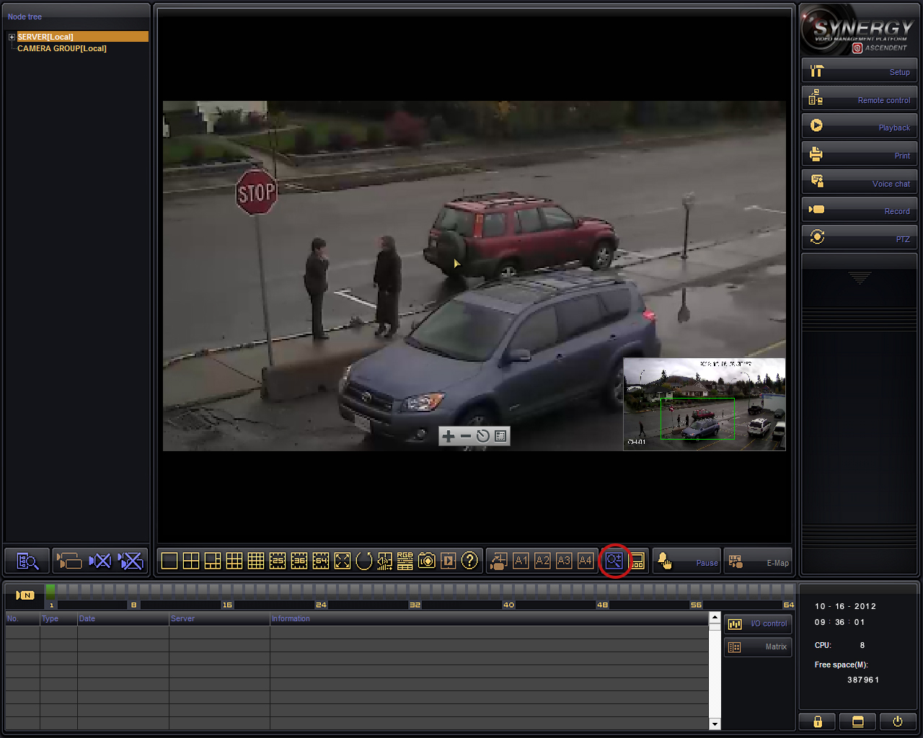(Fig. 2-0)

PTZ (presets)

Open the PTZ menu

Select the PTZ button to the right of the main video screen(s). (Fig. 3-0)

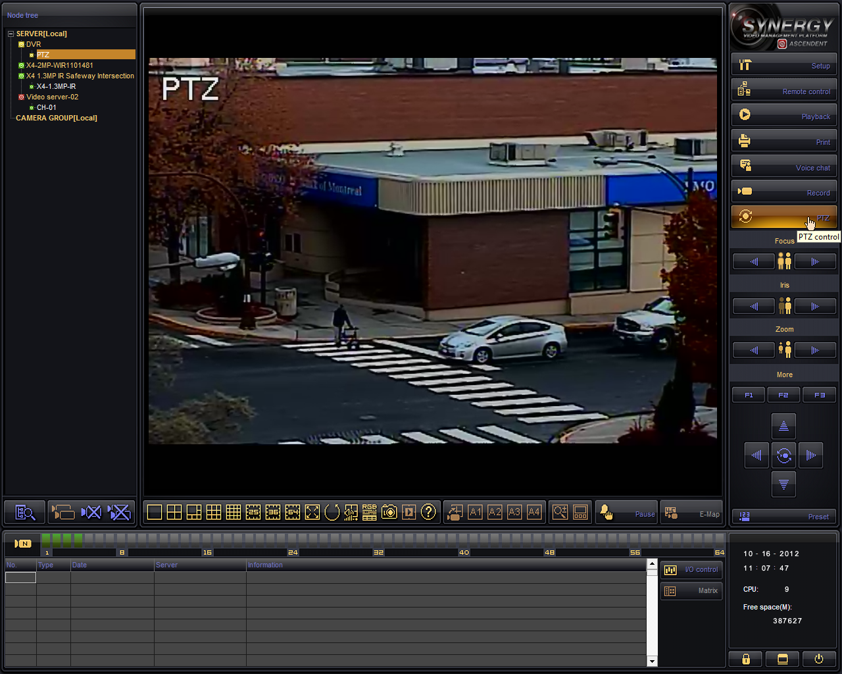
(Fig. 3-0)

Using the arrows or the cursor on the screen, position the PTZ camera to the desired position. Then press the Preset bottom located at the bottom on the PTZ controls. Select which number you would like to save the preset in and then click Save. (Fig 3-1) To view a preset simply click the number and then click Locate.

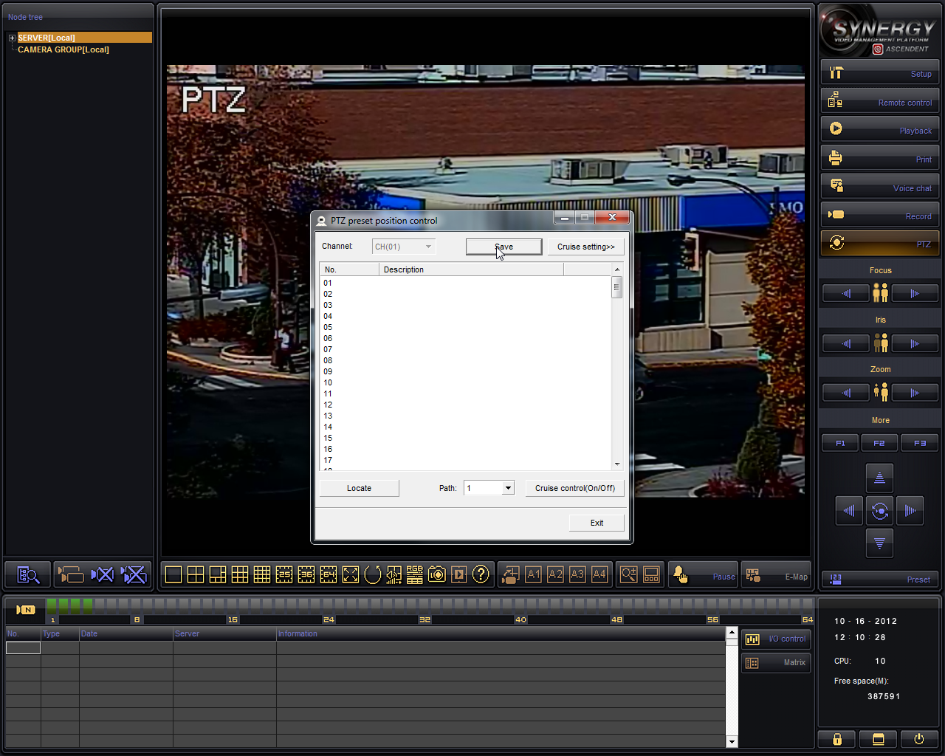
(Fig. 3-1)

Playback

Open the Playback menu

Select the Playback button to the right of the main video screen(s). You should see the following appear (Fig 4-0):

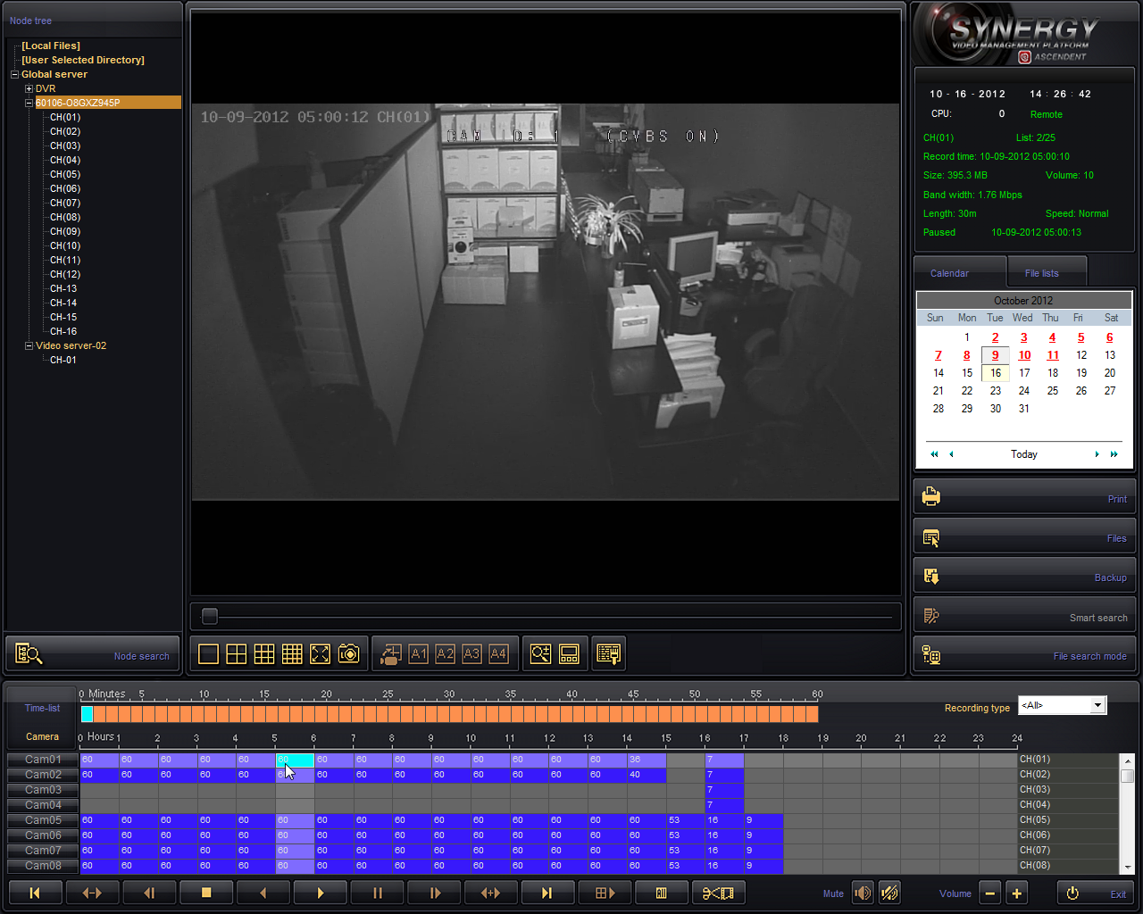
(Fig. 4-0)

Under the “Global server” heading on the left, double-click the DVR/device you would like to load playback from. Then, using the calendar (white box) to the right of the screen, choose the date of playback you would like to view. Next double-click an “Hours” box near the bottom of the screen (blue in this example) to view a specific time. To be even more accurate, double-click a “Minutes” box (peach colored in our example).

